2023 International Summer Camp

Venue: Lagoon Leisure Center, PA1 1NB

Dates: Friday 18th to Sunday 20st August 2023

Times: Friday 17:00 to 18:00 Registration
Friday 18:00 to 20:00 Training
Saturday 10:00 to 12:30 Training
Saturday 12:30 to 15:00 Grading
Sunday 10:00 to 13:00 Training

Kawasoe Sensei Maestro Naito
JKA WF JKA WF Italy
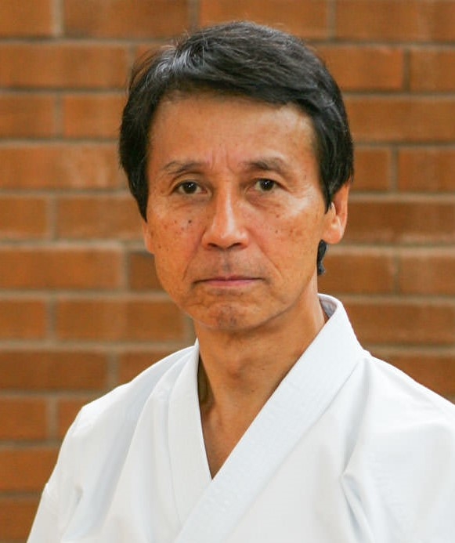
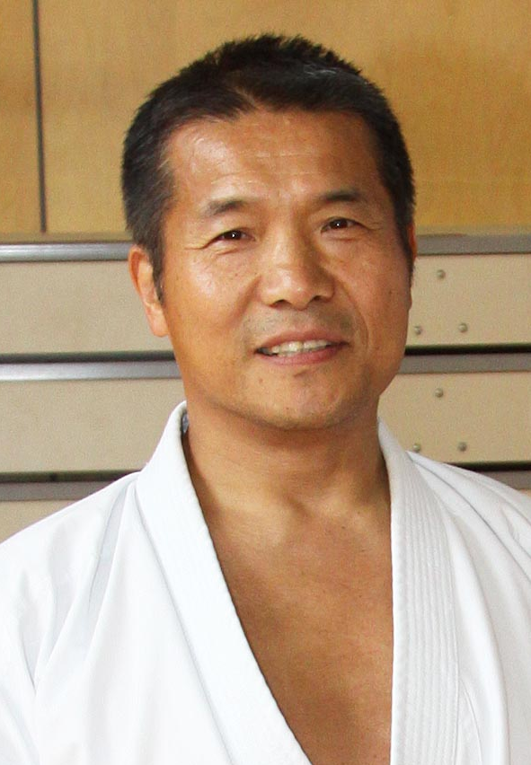

For applications to train or grade see separate forms.

